Integrated Time and Attendance System (ITAS):

AO/EMP/TK Requests Excused Absence w/ Drop-down

Role: Admin Officer, Employee, Timekeeper

Logging In
To log into the Integrated Time and Attendance system (ITAS) go to https://itas.nih.gov. Click the login button, use your PIV card and pin. If you are exempt from using your PIV card, click the non-PIV login page link. Once logged into ITAS, select the Admin Officer or Employee or Timekeeper role.

Excused Absence Leave Requests
As an AO/TK, clicking the link in the Leave Requests column in the Dashboard or clicking the Leave
Requests tab in the employee’s profile displays the Leave Request screen; as an Employee, one can click Request Leave. Requests can be submitted for a past, future, and/or current pay periods. Requests can be submitted for a full day or multiple days.

Leave Request
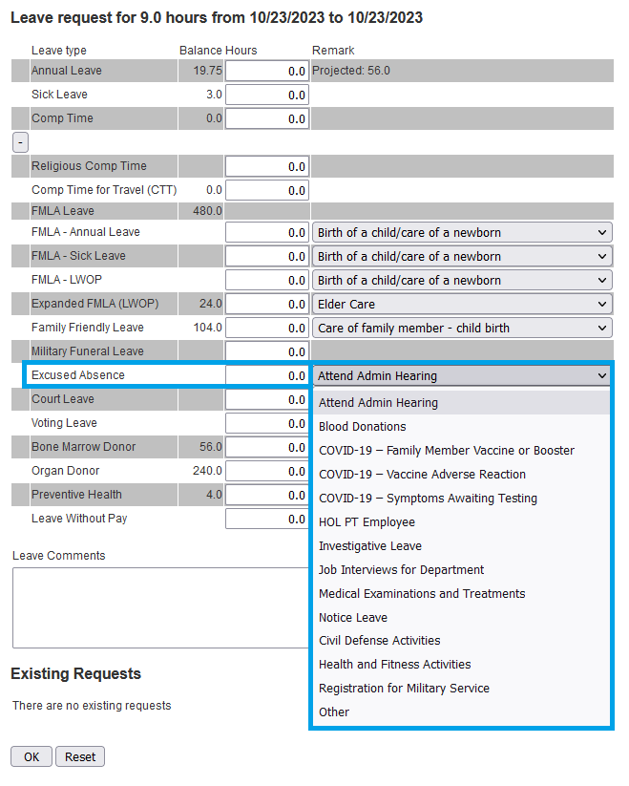
- Click the + button to show the Leave Request expanded view.
Figure 1: Excused Absence Leave Request
- Fill in the Start Date.
- Fill in the End Date.
- Click the Calculate Hours link.
- Enter the hours in the Excused Absence field, see “Figure 1”.
- Select pertinent Remark from the adjacent drop-down menu.
- If ‘Other’ is selected, entering text into the ‘Leave Comments’ field is required.
- Click OK button.
- Click OK on confirmation page.

Cancel existing requests
- Scroll down to the Existing Requests section.
- Check the Delete box(es) next to the requests.
- Click OK button.
- Click OK on confirmation page

Rules for Excused Absence Leave Requests
If an employee is requesting excused absence, a drop-down selection is now required; if ‘Other’ is selected, then a comment describing the leave is required.
Excused Absence can no longer be directly applied to a timecard, the leave must be requested.
Previously approved Excused Absence can have the hours reduced on a user’s timecard, but not added.

